Questionable Political Allegiance

- Or -

the Heidegger File

Index- 1
1NC Shell- 2

LINKS

Tech - 8
Communications - 12
Politics - 13
Thought Action Dichotomy- 15
Metaphysics- 16
Normative Thought- 17
World Peace- 18
Causality- 19
Instrumentality- 20

Meditative Thought

Checks Calc Thought- 21
Explanation- 22

Answers

Nazism- 24
Rawls- 25
General K of Digger- 26
Pragmatism - 27
Positive peace- 28
Fw- 29

Alt

Rethink Thought Alt- 30
Poems- 31

The prime failure of the affirmative is the way in which it goes about knowing. The 1AC is an example par excellance of calculative and technological thoguht- in their rush to action and knowledge, the affirmative has utterly marginalized meditative thought; in doing so, they privilege a mode of knowing that is fundamentally violent. Rather than bringing-forth knowledge, technology represents a violent challenging of the called-upon item. While the process of revealing is not essentially violent, the challenging endemic to technology is a dominating mode of knowing which seeks to master its object and reduce it to knoweable, usable standing reserve.
Hilde M. Zitzelsberger, Faculty of Nursing @ U. of Toronto, 2004
[“Concerning Technology: Thinking with Heidegger”; Nursing Philosophy, v. 5, issue 3, pg 242-250.]
That revealing is the essence of modern technology, as described by Heidegger in his thinking about techne, is not a simple or straightforward matter and thus requires further questioning. Modern technology's essence reveals, but is an unconcealment that opens up in a specific way, a challenging-forth rather than a bringing-forth in the sense of poiesis. Heidegger highlights the divergence between techne as poiesis and techne as modern technology.
The revealing that holds sway throughout modern technology does not unfold into a bringing-forth in the sense of poiesis. The revealing that rules modern technology is a challenging [Herausfordern], which puts to nature the unreasonable demand that it supply energy which can be exacted and stored as such. (p. 320)
Heidegger considers the crucial question of the difference between modern technology developed from industrial times onwards and older forms of technology. The aggressiveness by which modern technology is called upon to reveal through challenging-forth stems from 'man's ordering attitude and behaviour' which 'display themselves first in the rise of modern physics as an exact science' (p. 326). The assumptions and work of western natural sciences, Heidegger tells us, 'prepares the way not simply for technology, but for the essence of modern technology' (p. 327).
It is said that modern technology is something incomparably different from all earlier technology because it is based on modern physics as an exact science. Meanwhile we have come to understand more clearly that the reverse holds true as well: modern physics, as experimental, is dependent upon technological apparatus and upon progress in building of apparatus. . . . Of what essence is modern technology that it thinks of putting exact science to use? (p. 320)
Modern physics as a system of epistemic representation acts upon nature demanding it report itself in some way or another through calculation and that it remain orderable' (p. 328). In this ordering, 'causality now displays neither the character of occasioning that brings forth nor the nature of the causa efficiens' (p. 328), along with the loss of accompanying sense of aition or responsibility as the Greek thought of it. The essential order of revealing of modern technology, which puts exact physical sciences to use is termed enframing (Gestell) by Heidegger.
Enframing means the gathering together of the setting upon that sets upon man, i.e. challenges him forth, to reveal the actual [everything], in the mode of ordering, as standing-reserve. Enframing means the way of revealing that holds sway in the essence of modern technology and that is itself nothing technological. (p. 325)
While what is technological is the apparatus of technology, for example, machine parts, the destining of modern technology's essence has a long history that precedes the apparatus of modern technologies, yet now orders available apparatus and ourselves for use. What is significant then, from older technologies to newer technologies, concerns domination of nature through technological modes of challenging-forth towards its own ordering. Thus, as Heidegger says, 'this work is therefore neither only a human activity nor a mere means within such activity. The merely instrumental, merely anthropological definition of technology is therefore in principle untenable' (p. 326).

Health Technology is specifically dangerous insofar as it concerns itself explicitly with revealing the human body. The health technology apparatus serves as a challenging upon the body, a means by which humans attempt to dominate the body and force it to bend to order, study, and knowing. Health technology is an enframing of the body, and in the process reduces the body to standing reserve, to be studied and modified and reordered. Technology dominates the body and pervades the medical system- even pay grades are determined by technologic means. This pervasive technologism sets humanity on a course where quite literally everything is reduced to standing reserve.

Hilde M. Zitzelsberger, Faculty of Nursing @ U. of Toronto, 2004
[“Concerning Technology: Thinking with Heidegger”; Nursing Philosophy, v. 5, issue 3, pg 242-250.]
I find Heidegger's views of technology particularly important to pursue in relation to health care and nursing practice as they uncover ways to understand technology's nature and movements, our relationship to technology, and all else appropriated by it. Heidegger's questioning of technology focuses on productive manufacturing, the entrapment of natural elements of the earth to produce available energy and materials in terms of 'maximum yield at the minimum expense' (p. 321). The rise of modern technology in processes of industrialization, underpinned by exacting physical sciences, expands as well to the technologies of scientific medicine and nursing. Here I extend Heidegger's work to my concerns in thinking of the body, health, and illness. In that modern technology both unconceals and conceals as it orders, how does the body become present when claimed by this technological viewpoint? I think here on scientific forms of knowledge by which the body becomes revealed. Like any natural resource, the body as an object of physical sciences can by studied in the ways that it has presences, in terms of its matter, form, function, chemicals, and physical movements. From this viewpoint, the body can appear as little more than physicality that is calculable, predictable, and thus, programmable to some extent. In a way similar to Heidegger's description of the Rhine or Bigwood's description of water in a hydroelectric plant, the body in phases of health and illness becomes known in a particular manner. Applied through human activities, technology as enframing separates itself from the body's originating processes enforcing an order of a different kind. Heidegger remarks that 'the essence of modern technology starts man on the way of that revealing, through which the actual [everything] everywhere, more or less, becomes standing reserve' (p. 329). In the sense that we can think of the body as standing-reserve for these projects, the body then is destined to be a resource whose naturalness can be unconcealed and therefore, manipulated, exploited, ordered, and reordered under the sway of technological means. Yet, through revealing the body and its processes in particular ways, other facets and processes become concealed and unknown.
In that technology's way of revealing has a long history in physical sciences, modern of health care technologies are enframed by it. The body revealed as standing reserve is commonplace within health care. Health care technologies are designed by humans to intervene in the function of the body to produce health or life in a form determined by human intentions. By extension, mastering technology that produces health or life leads to the mastery of disease, illness, and death, rather than the cultivation of natural processes of healing, decline, or death. The body now is called on to move to technological rhythms rather than fundamental biological rhythms. Through surgery or drugs, the body can be forced to follow a course not of its original order by use of life-sustaining technologies, such as dialysis or transplants. I think of this in regard to chronic illness and disabilities in which life may be prolonged through challenging the body or parts of the body to continue in artificial ways that do not reproduce the original order of the body. The task of genetic intervention, inside or outside the womb, is to uncover diseases, such as mental and physical disabilities not yet manifest, and to manipulate their order so that their original experiential course is thwarted. While beneficial and to be welcomed at times, notions of control of the body's processes perpetuate and promote further precedents. Our successful manipulations of the body's function to date has moved debates on to the subjects of harvesting fetal or organ tissues to alter diseases, cloning, reproductive technologies, and turning off the body's energy through abortion, assisted suicide, or other technological means.
Nursing work has become increasingly reliant on health-care technologies to provide knowledge of and care to patients. From this vantage point, those who work in health-care institutions are not mere technicians in these technological enterprises. In effect, patient and practitioner alike become claimed by technology as standing reserve. Heidegger remarks that:
Only to the extent that man for his part is already challenged to exploit the energies of nature can this revealing that orders happen. If man is challenged, ordered to do this, then does not man himself belong even more originally than nature within the standing reserve? (p. 323)
In the politics and economy of health care, that which is technological is granted the priority form of care. In health-care systems, people who work closest to the body in nontechnological or lower-technological ways, such as personal care attendants and nurses, for the most part, are socially positioned as lower status within technological hierarchies, whereas those who work at a greater distance from the body through technologies are granted more social privilege and status. I think here also of medical research about the body in which studies of the body's originating processes and the ways that these processes can be technologically tampered with drive our research agendas and funding. Heidegger tells us that in technological systems, we are both resource and gathered as the orderer of standing reserve.
The flight from meditative thought is dangerous insofar as the ease with which calculative thought is undergone may well beguile humanity into accepting it as the only mode of thought- this flight from thought is perhaps more dangerous than a third world war- as while a world war has the potential to destroy humanity, a world in which calculative thought has destroyed meditative thought denies humanity its central and unique role as a thinking being.

Martin HEIDEGGER, revolutionizer of western thought and slayer of metaphysics, 1966
[Discourse on Thinking; Harper & Row, 1966; pg. 55-6]

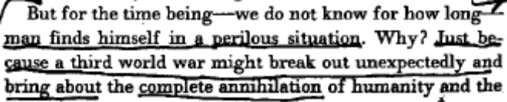
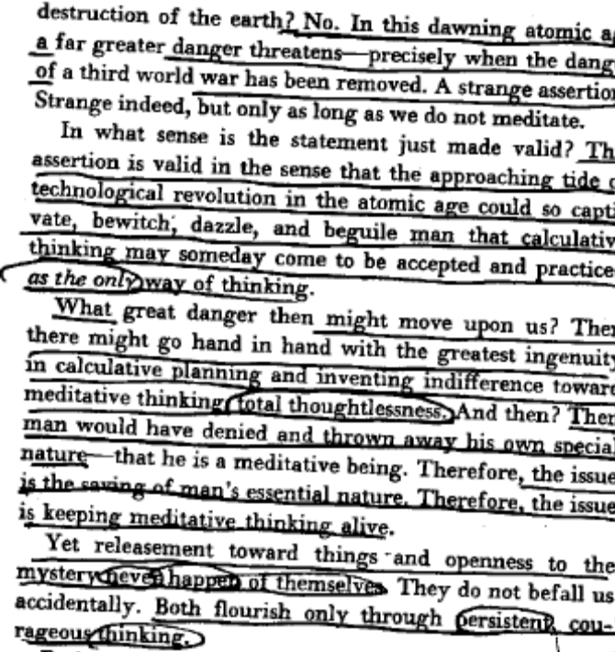

The danger of calculative thought lies in its propensity to become the only form of thought. However, this danger may be rectified with the proper effort and determination- calculative thought is vulnerable to contemplation and reflection. Thus, by pitting meditative thought against calculative, it becomes possible for us to achieve a relationship with technology wherein we are able to utilize its benefits, but keep its dangers firmly in check. This relationship, which Heidegger refers to as a releasement towards things, is a contemplative intellectual stance which seeks to allow knowledge of things to disclose itself rather than to violently know that thing.

Martin HEIDEGGER, revolutionizer of western thought and slayer of metaphysics, 1966
[Discourse on Thinking; Harper & Row, 1966; pg. 52-5]

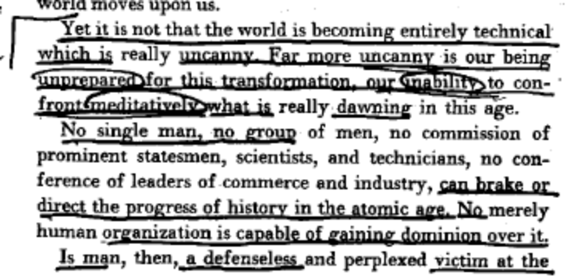
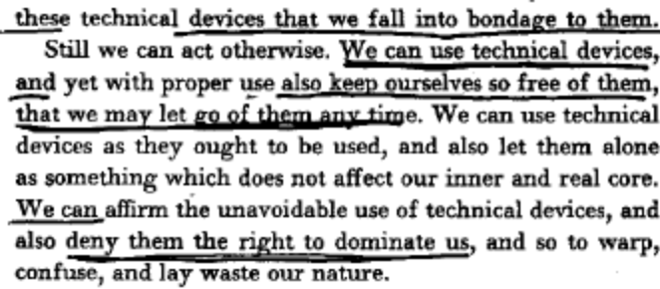
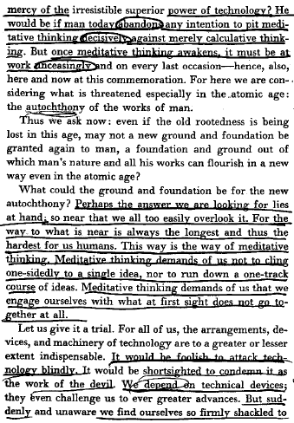
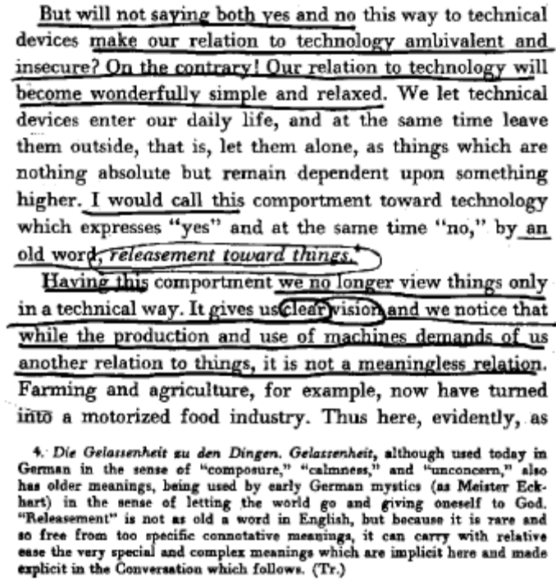
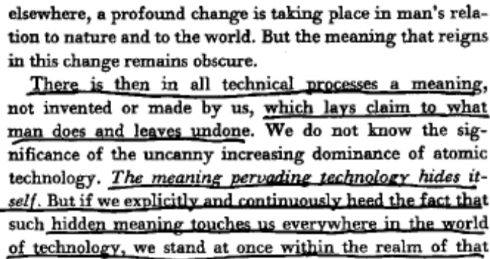

In order to enter into a meditative relationship with Africa and the resolution, it seems necessary to attempt to experience Africa in a different manner. It is possible to do so via an attempt to relate to Africa poetically, for poetry represents the very extreme of thought- contemplative, open, meditative- that we must resort to in order to correc the trend towards calculation.

Alvin H. ROSENFELD, Professor of English @ U. of Indiana, 1976
[“The being of Language and the Language of Being: Heidegger and modern Poetics,” Boundary 2 vol. 4 issue 2, pp. 535-553]

To a poet as poet, this moment comes as an experience with and through language. What does it mean "to undergo an experience with language"? The question is implicit in much of Heidegger's late writings but is raised explicitly in "The Nature of Language." It will be useful to look briefly at what he says in this important but exceptionally difficult essay and then go on to examine some poems that attempt to express, as a major part of their progress into poetry, what it means to undergo an experience with language. "To undergo an experience," writes Heidegger, “means that something befalls us, strikes us, comes over us, overwhelms and transforms us. . . . The experience is not of our own making; to undergo here means that we endure it, suffer it, receive it as it strikes us and submit to it.. . . To undergo an experience with language, then, means to let ourselves be properly concerned by the claim of language by entering into and submitting to it. If it is true that man finds the proper abode of his existence in language - whether he is aware of it or not - then an experience we undergo with language will touch the innermost nexus of our existence.” (p. 57) By the forcefulness of this description, it is clear that Heidegger has in mind a more than ordinary relation to language. "It could be," he conjectures, "that an experience we undergo with language is too much for us moderns" (p. 58),that we prefer instead a more distant or more strictly utilitarian relationship to language, one in which we use it rather than have it possess us. But such an attitude reduces language to something less than itself - Heidegger calls it "metalanguage," the information gathering and distributing medium of a technologized civilization - and consequently reduces us to something less than ourselves. For if language cannot be brought to voice more purely and authentically, then something in us goes mute as well. Yet Heidegger maintains that from time to time, and especially "when the issue is to put into language something which never yet has been spoken," words may come to life in unexpected and particularly striking ways. At such times poetry is born, and "a poet might even come to the point where he is compelled - in his own way, that is, poetically - to put into language the experience he undergoes with language" (p. 59). It is precisely this experience that I am interested in searching out in poetry, a poetry full enough and close enough to "touch the innermost nexus of our existence." Where does one find such poetry?

KNOWING ROBS US
Chinua Achebe, [http://www.randomhouse.com/boldtype/1298/achebe/scrapbook.html]
Knowing robs us of wonder.
Had it not ripped apart
the fearful robes of primordial Night
to steal the force that crafted horns
on doghead and sowed insurrection
overnight in the homely beak
of a hen; had reason not given us
assurance that day will daily break
and the sun's array return to disarm
night's fantastic figurations--
each daybreak
would be garlanded at the city gate
and escorted with royal drums
to a stupendous festival
of an amazed world.
One day
after the passage of a dark April storm
ecstatic birds followed its furrows
sowing songs of daybreak though the time
was now past noon, their sparkling
notes sprouting green incantations
everywhere to free the world
from harmattan death.
But for me
the celebration is make-believe;
the clamorous change of season
will darken the hills of Nsukka
for an hour or two when it comes;
no hurricane will hit my sky--
and no song of deliverance.

LINK: TECHNOLOGY

The way in which technology reveals concerns its object is as resource. This process of enframing nature as an instrument to be made ready-at-hand. Technology represents the drive to order, know, capture, distribute, UTILIZE all that which is at present unknown and unknoweable. This conception of nature as that which is to be utilized reduces its object to pure standing reserve, to be utilized or expended as necessary.
Hilde M. Zitzelsberger, Faculty of Nursing @ U. of Toronto, 2004
[“Concerning Technology: Thinking with Heidegger”; Nursing Philosophy, v. 5, issue 3, pg 242-250.]
Modern technology's way of revealing concerns nature as resource. Through enforced demanding of natural processes, Heidegger describes the mode of revealing that is imposed by modern technology.
The revealing that rules throughout modern technology has the character of a setting upon (das Stellen), in the sense of challenging-forth. Such challenging happens in that the energy concealed in nature is unlocked, what is unlocked is transformed, what is transformed is stored up, what is stored up is distributed, what is distributed is switched about ever anew. Unlocking, transforming, distributing, and switching about are ways of revealing. (p. 322)
To illustrate, Heidegger outlines modern technology's grip on nature, in the sense of challenging-forth, through his description of a hydroelectric plant set in the flow of the Rhine River, which harnesses the river's energy commanding it for energy production industries as well as the river's natural beauty structured now for tourism. Heidegger asks: 'What kind of unconcealment is it, then, that is peculiar to that which results from this setting-upon that challenges?' (p. 322).
Everywhere everything is ordered to stand by, to be immediately on hand, indeed to stand there just so that it may be called upon for a further ordering. Whatever is ordered about in this way has its own standing. We call it standing reserve [Bestand]. (p. 322)
Unlike revealing brought-forth by poiesis, modern technology's challenging-forth regulates the structure and temporality of nature. Carol Bigwood (1993) in her essay The Being of Water in the Hydroelectric Plant draws on Heidegger's work to illustrate technology's approach to the fluidity of water and movements of livestock whose energies are unlocked, transformed, stored, and switched as standing resources for manufacturing products for human consumption. Her essay highlights that 'the movements of beings' are underpinned by an Aristolelean sense of movement. Under technology's sway, beings do not merely 'pass from here to there but in a broader sense as something changing from this to that, and ultimately as the dynamism of Be(com)ing, itself' (p. 224). As such, natural courses of entities are fundamentally challenged to move differently than their originating order, in so far as possible. Unconcealed as standing reserves through technology, the ontological status of entities becomes fundamentally concealed, redirected, or eradicated.

LINK: TECHNOLOGY

The dominance of the calculative mode of thought comes to a head in the dominance of science and technology. These twin impulses drive humanity ever forward in a driving form of progress which views all that is as nothing but useable resource, as standing reserve. The question quickly shifts from that of useage to that of mastery- and all the while, this mode of knowing refuses to stop and reflect upon its ideas. All the while, the destructive impulse of calculative thought runs utterly unchecked and will quickly grow beyond our control.

Martin HEIDEGGER, revolutionizer of western thought and slayer of metaphysics, 1966
[Discourse on Thinking; Harper & Row, 1966; pg. 49-51]

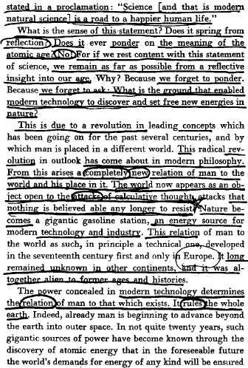
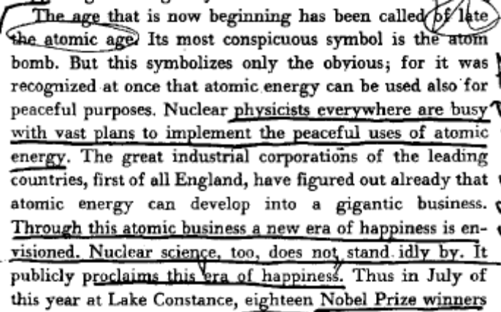
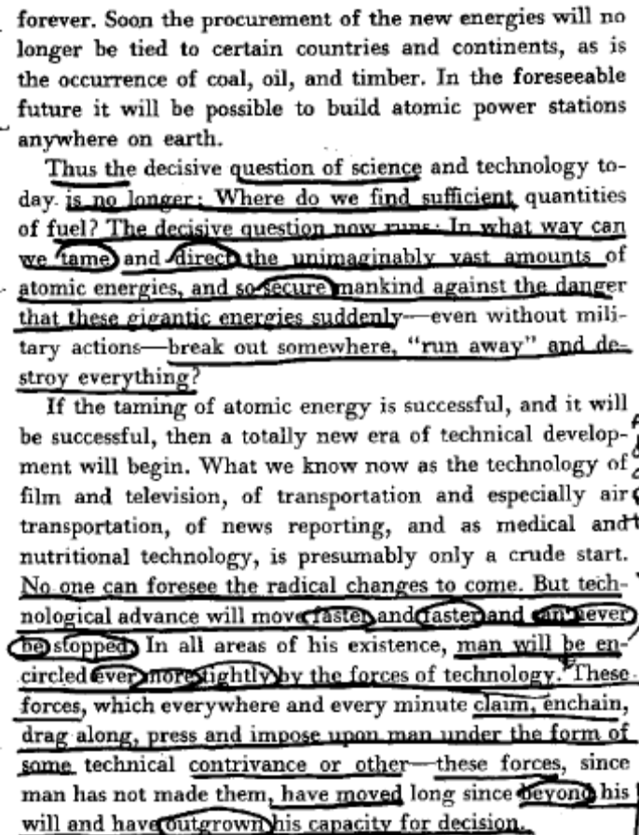

Link: political Theory/ Technological thinking

Political theory and appeals to progress are not sufficient excuses for calculative thought- the political project is based firmly in unquestioned and unchallenged modes of thought which are incredibly destructive.

Norman K. SWAZO, Prof. of Philosophy @ U. of Alaska- Fairbanks, 2002
[Crisis Theory and World Order: Heideggarian Reflections; SUNY Press; pg. 119-122]
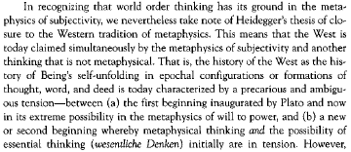
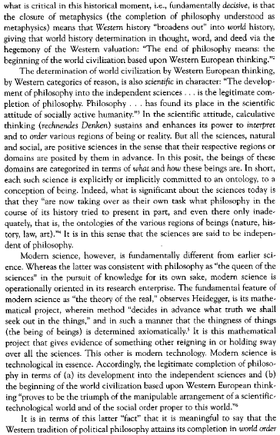
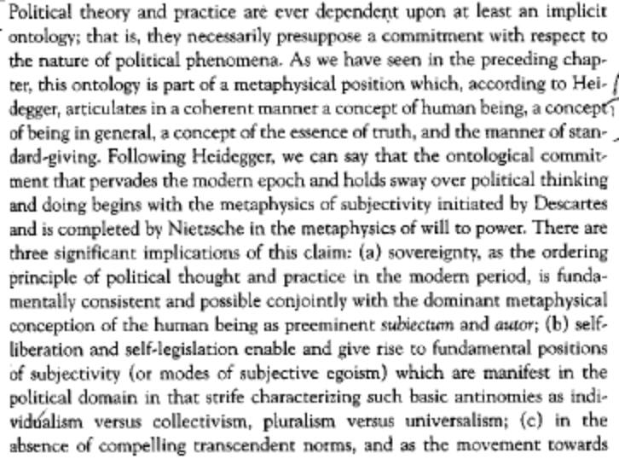
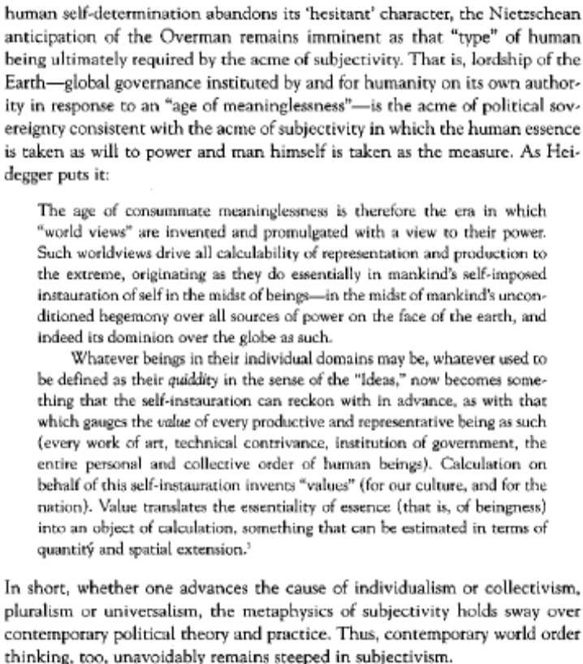

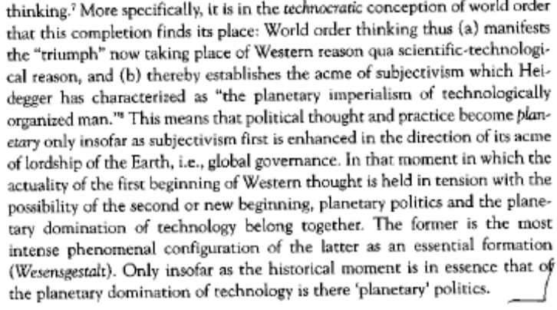

LINK: COMMUNICATIONS TECHNOLOGY

Communications technology is far more problematic than the vision presented by the affirmative. While such technology may indeed enable us to connect to faraway places, this comes at the expense of utter alienation from our essential habitats. The promise of technology is nothing more than a world in which we are more deeply connected to imaginary worlds on screens than our immediate surrounding.

Martin HEIDEGGER, revolutionizer of western thought and slayer of metaphysics, 1966
[Discourse on Thinking; Harper & Row, 1966, pg. 48-9]

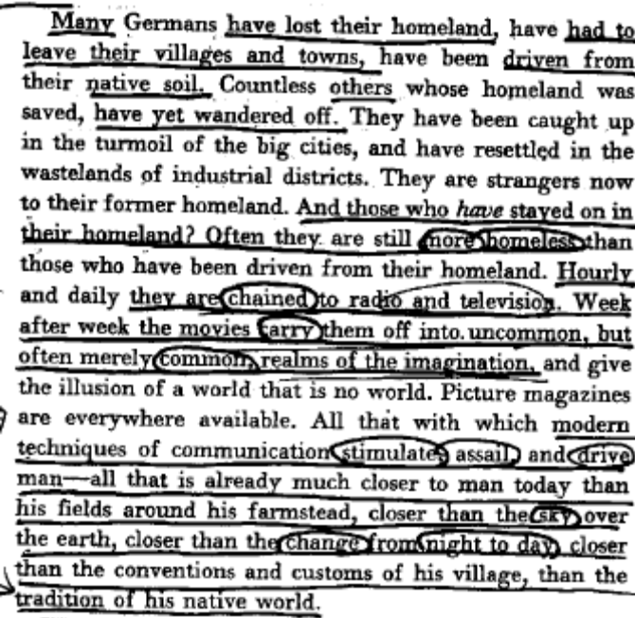

LINK: POLITICS

Link: politics/political process

The political process is an inherently calculative one- politics is driven along without pause for reflection or contemplation, and political theory exemplifies the sort of programmatic unthought that charachterizes the modern era.

Norman K. SWAZO, Prof. of Philosophy @ U. of Alaska- Fairbanks, 2002
[Crisis Theory and World Order: Heideggarian Reflections; SUNY Press; pg. 67-9]
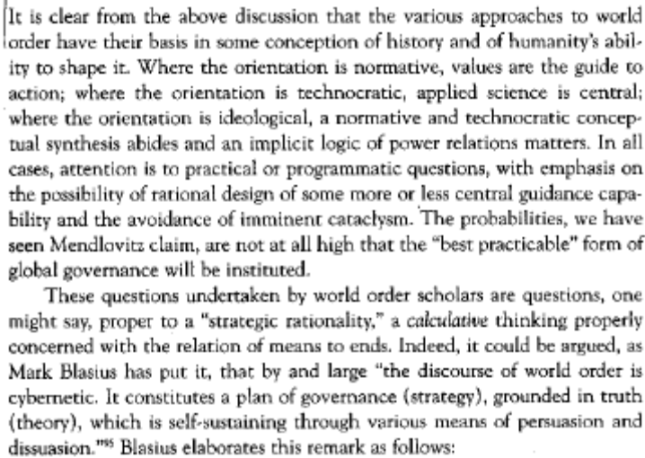

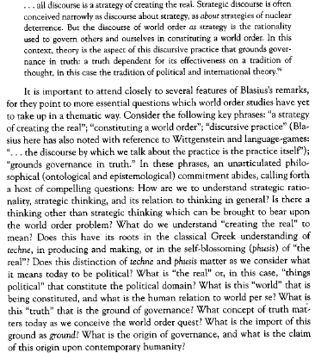
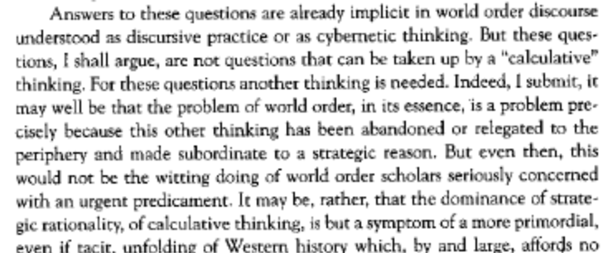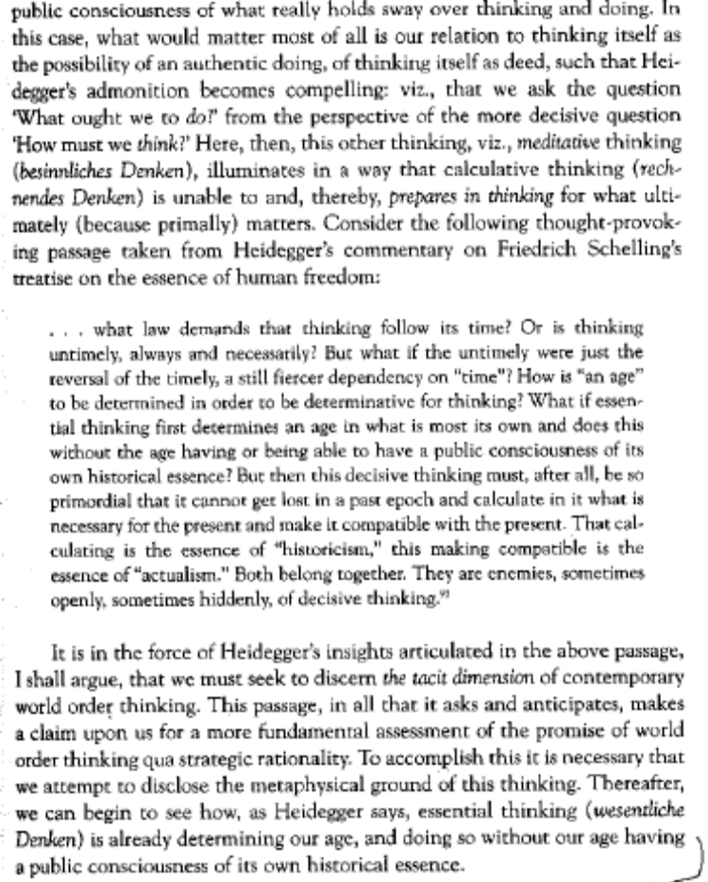

Link: Any form of politics

The appeal to [democracy, socialism etc.] is rooted in judeo-christian calculative morality- this ethic machinizes and technicizes the human experience.

Norman K. SWAZO, Prof. of Philosophy @ U. of Alaska- Fairbanks, 2002
[Crisis Theory and World Order: Heideggarian Reflections; SUNY Press; pg. 114-5]

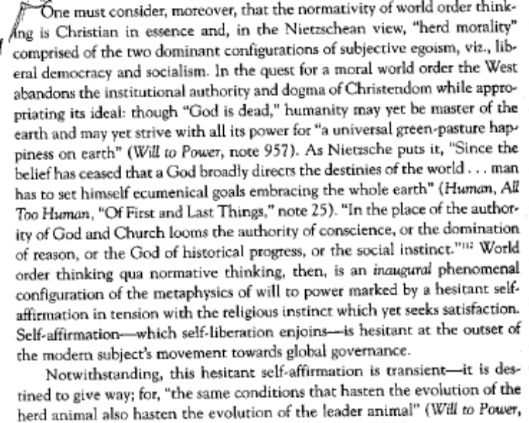
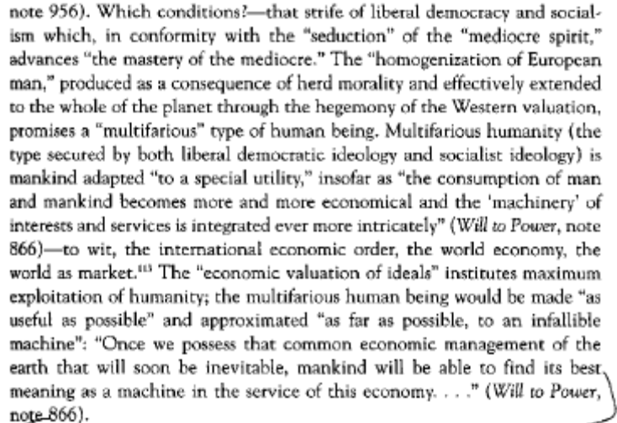

LINK: THOUGHT/ACTION DICHOTOMY

Link: Thought/Action Dichotomy

By positing action as over and exclusive of thought, Western Metaphysics makes impossible a break from modernity’s destructive privileging of calculative thought.

Norman K. SWAZO, Prof. of Philosophy @ U. of Alaska- Fairbanks, 2002
[Crisis Theory and World Order: Heideggarian Reflections; SUNY Press; pg. 179-80]

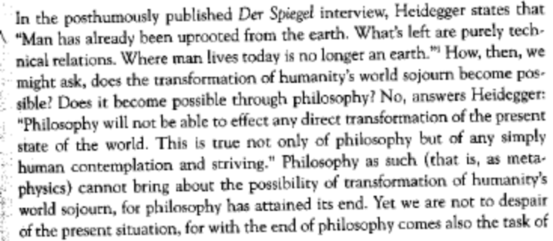
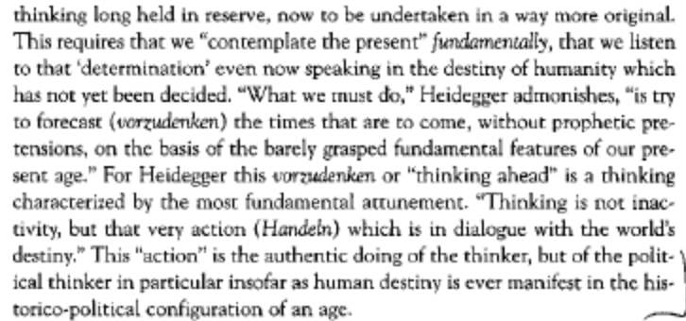

Link: Metaphysics
Insofar as it is grounded in western metaphysics, the Affirmative is complicit with the light from thought that characterizes the danger of the modern project. Metaphysical critique is simply not enough- we must cut through the centuries of ‘enlightenment’ and address deeper questions of thought and being.

Norman K. SWAZO, Prof. of Philosophy @ U. of Alaska- Fairbanks, 2002
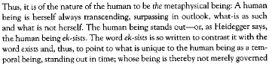
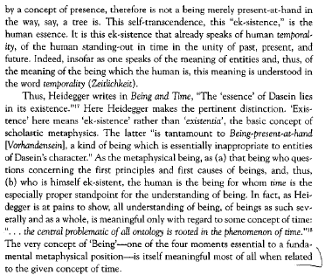
[Crisis Theory and World Order: Heideggarian Reflections; SUNY Press; pg. 77-9]
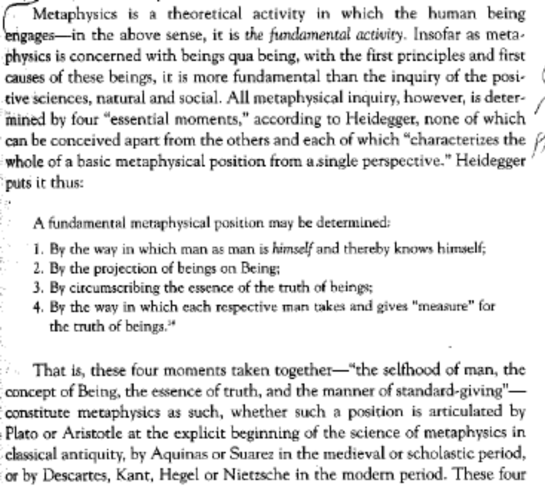
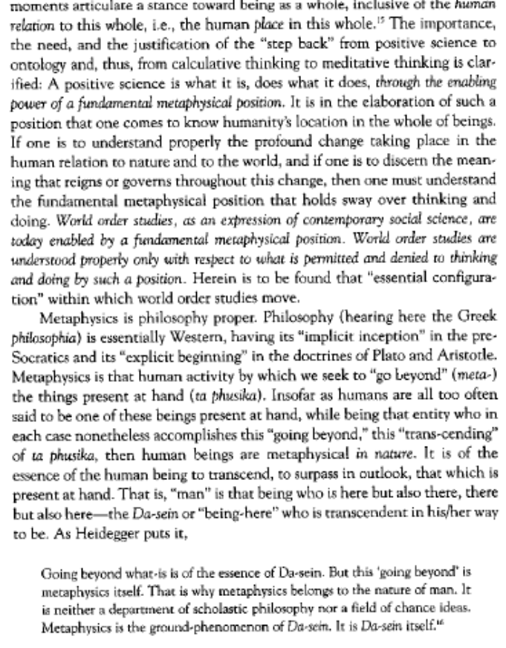

Link: Normative Thought

Normative thought is grounded in calculative western violence.

Norman K. SWAZO, Prof. of Philosophy @ U. of Alaska- Fairbanks, 2002
[Crisis Theory and World Order: Heideggarian Reflections; SUNY Press; pg. 112]

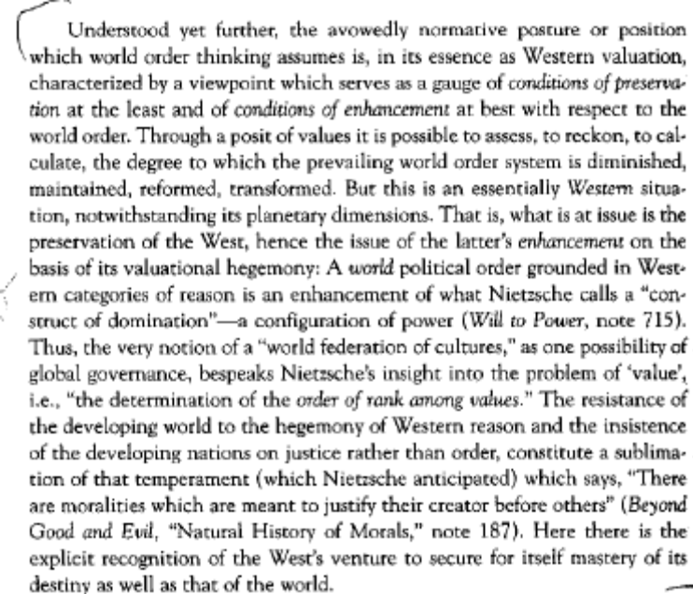

Link: World Peace/order

The appeal to global order and peace is inextricably tied up in the flight-from-thought that accompanies the modern project. This appeal is grounded firmly in calculative thought.

Norman K. SWAZO, Prof. of Philosophy @ U. of Alaska- Fairbanks, 2002
[Crisis Theory and World Order: Heideggarian Reflections; SUNY Press; pg. 72-3]
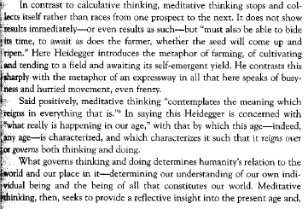
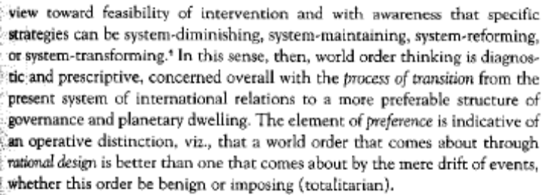
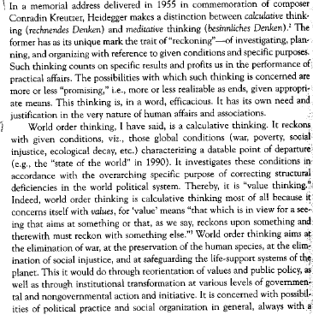
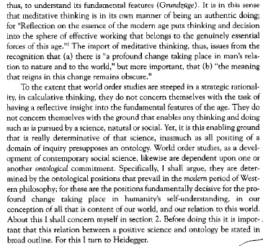

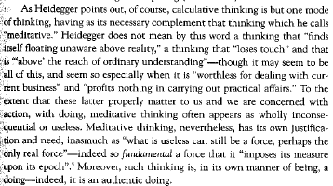

LINK: CAUSALITY
The affirmative’s conception of causality as purely action-reaction neglects myriad other ways in which things come into being. By situating human action as the primary determinant of outcome, the aff prevents serious questioning of the process of becoming. This situation of humanity as agent of causation is an attempt to violently order our existence and is an act of enframing that treats its object as nothing but instrumental material to be used.
Hilde M. Zitzelsberger, Faculty of Nursing @ U. of Toronto, 2004
[“Concerning Technology: Thinking with Heidegger”; Nursing Philosophy, v. 5, issue 3, pg 242-250.]
Seeking the 'true' through the correct provides a path into unveiling the essence of technology, obscured by an instrumental definition of technology. Heidegger questions: 'What is the instrumental itself? Within what do such things as means and ends belong?' (p. 313). He explains that 'whenever ends are pursued and means employed, whenever instrumentality reigns, there reigns causality' (p. 313). For Heidegger, unveiling causality along with corresponding conceptions of technology is necessary to move beyond the correct toward uncovering technology's essence. The primal meaning of causality, as thought by the Greeks and to which means and ends belong, was once known more completely. The deeper and broader significance of causality are disclosed by Heidegger through recovering the Aristotelian four causes: (1) causa materialis (the matter of which something is made); (2) causa formalis (the form into which matter is shaped); (3) causa finalis (the telos which binds together the aspect (eidos or idea) and matter that gives bounds to the form and begins the purposeful life of the creation); and (4) causa efficiens (that which brings the finished effect).
Expanding the complex forces and elements by which things come forth into appearance, Heidegger includes notions of responsibility and indebtedness. In Greek thought to which Heidegger returns us, the four causes are aition'that to which something else is indebted' and 'being responsible for something else' (p. 314). The four causes together are coresponsible and indebted to one another for the presencing of what appears. Heidegger states:
The principle characteristic of being responsible is this starting something on its way into arrival. It is in the sense of such a starting something on its way into arrival that being responsible is an occasioning or an inducing to go forward. (p. 316)
In the creation of something, the four undividable causes that await ordering are gathered together contemplatively to manifest something that can depart, beginning its life and purpose. Heidegger finds that if we understand the essence of causality as occasioning, a bringing-forth into arrival by way of the four causes, then we grasp causality as responsibility in the sense that the Greeks thought it. The revealing movements of the four causes are punctuated by Heidegger through revisiting the verb cadere, to fall, to which the word causa belongs. Considering causality as falling rather than producing an effect or outcome determined in advance suggests other ways of occasioning than notions of a linear projection of means to end brought about by the collected elements of the four causes through human mastery.
Significant to our contemporary situation, Heidegger points out that the notion of cause as producing predetermined effects or outcomes conceals all other dimensions of causality. Heidegger draws attention to our current state in which 'the causa efficiens, but one of the four causes, sets the standard for all causality.' (p. 314). He states that 'this goes so far that we no longer count the causa finalis, telic finality, as causality' (p. 314), that which bound the creation to beginning its purposeful life. When everything is viewed within this schema of means–ends, Heidegger remarks, even in theologies 'God can sink to the level of a cause, of causa efficiens' (p. 331). Moreover though, in a time of modern technology, we view ourselves as fundamental agents of production. Technology is held up as the instrumental means by which we bring about ends which we have scientifically projected as possible. Taking ourselves to be the domineering cause efficiens, contained in our attempts to master technology as an instrument is the intent to order all which can be subject to technological causality. Highlighting the difference between causality in a more complete sense as occasioning and the limited modern sense of causality that is related to technology, Heidegger questions the notion of technology, with us at the helm, as the sole means that produces effects and attains outcomes.
If we recognize that technology is not merely an instrumental means to an end for human enterprises, then we can question further the nature of technology. To think about technology in its essence, Heidegger states, we must 'take seriously the simple question of what the name "technology" means' (p. 318). He probes the deeper significance of technology, in conjunction with the four modes of occasioning, through an etymological understanding of the Greek word techne, from which technology derives. Heidegger states that techne once meant more than technology as a 'contrivance – in Latin, an instrumentum' (p. 312) as typically thought in contemporary times.

LINK: INSTRUMENTALITY

Our conception of Technology cannot be relegated to simply that of instrumentality- to do so prevents us from thinking technology in alternate ways that may bring us into a proper relation to it. By approaching technology as neutral instrument, the affirmative disregards the ways in which technology escapes human mastery. Our relation to it must not be concieved in terms of mere instrumentality- without THINKING technology, our responses will turn increasingly violent as we find again and again that it escapes our mastery.

Hilde M. Zitzelsberger, Faculty of Nursing @ U. of Toronto, 2004
[“Concerning Technology: Thinking with Heidegger”; Nursing Philosophy, v. 5, issue 3, pg 242-250.]
Modes of thought that describe technology are taken up by Heidegger as he develops thinking about technology in order to open us to its essence so that 'we shall be able to experience the technological within its own bounds' (p. 311). Instrumental and anthropological characterizations of technology as 'a means to an end' and 'human activity' (p. 312) commonly hold sway in contemporary times. While these definitions correctly hold from more antiquated to modern technologies, from the sawmill to the hydroelectric plant, inquiries about technology cannot be consigned to discourses of instrumentality nor terminate in the project of modern natural sciences, for example physics or mathematics. In regard to modern natural sciences, Heidegger explains that:
Through its so doing the deceptive appearance arises that modern technology is applied science. This illusion can maintain itself precisely insofar as neither the essential province of modern science nor indeed the essence of modern technology is adequately sought in our questioning. (p. 328)
Heidegger indicates that such critiques return to their own representations, eluding questioning that can probe technology's essence, its possibilities and dangers. Thus, solely scientific and instrumental conceptions of technology block questioning of technology's essence and 'conditions every attempt to bring man into the right relation to technology' (p. 313). If we take this neutral stance, Heidegger remarks that:
Everything depends on our manipulating technology in the proper manner as a means. We will, as we say, 'get' technology 'intelligently in hand'. We will master it. The will to mastery becomes all the more urgent the more technology threatens to slip from human control. (p. 313)
Reliance on notions of human mastery of technology when technology is viewed as an instrument extends to and intensifies pursuit of mastery over that which technology can invest and control, such as natural and physical processes whether those of rivers, land, or bodies, health, and illness.

Meditative thought functions as a corrective to the propensity to rely solely on calculative thought. However, this form of thought requires intense effort and determination, and cannot be undertaken lightly. With courage and persistence, we can engage thought in such a way as to make an opening towards being and mystery possible- yet, this releasement towards being can only come into presence with purposeful effort.

John m. ANDERSON, 1966
[Introduction to Discourse on Thinking by M. Heidegger; trans. John M. Anderson & E. Hans Freund; Harper & Row; 1966]

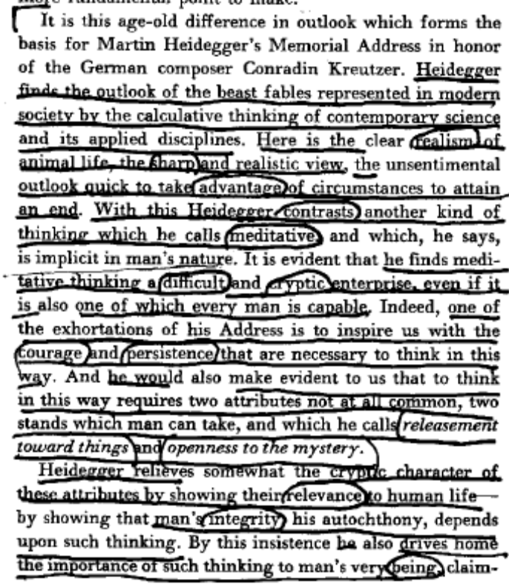
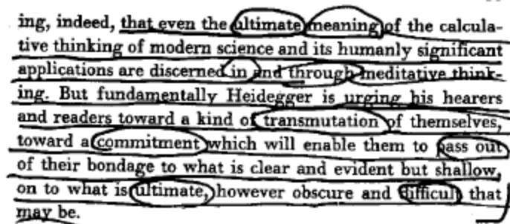

Meditative thought differs from calculative thought in its fundamental essence- meditative thought eschews the urgent call to act, create, and most of all to know a thing or concept. Instead, it is characterized by a profound stillness, a disavowal of immediacy and urgency, to be replaced by a painstaking stillness, in which an openness towards being emerges. meditative thought allows the thinker to come to know differently, in such a way as to comprehend Being on its own terms; rather than violently ordering Being, meditative thought allows Being to disclose itself. This releasement towards being is an essential component of human thought.

John m. ANDERSON, 1966
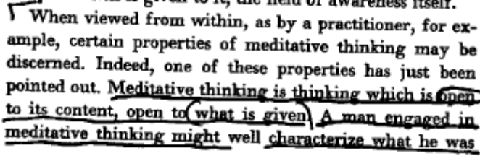
[Introduction to Discourse on Thinking by M. Heidegger; trans. John M. Anderson & E. Hans Freund; Harper & Row; 1966]
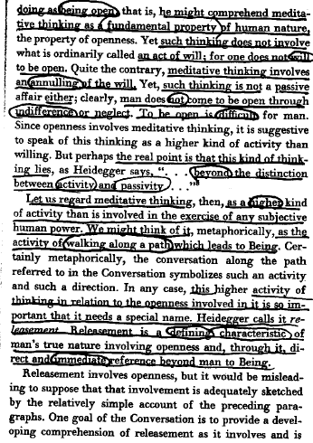
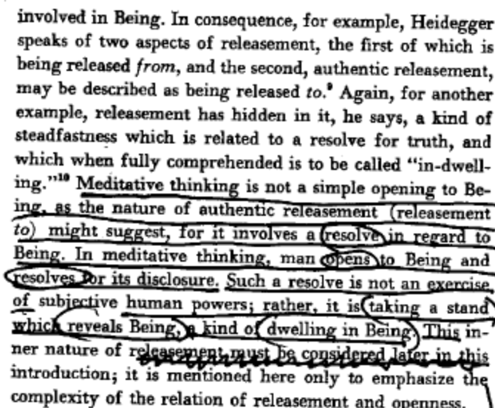

There exist two forms of thought endemic to the human mind. The first is known to critics as calculative thought. This form of thought is planning, investigatory, and predictive. It immediately seeks to know that which it encounters, and refuses to contemplate or reflect. Calculative thought represents a flight-from-thinking, a turning-away from true thought. The other form is meditative thought. Meditative thought contemplates, reflects, is still, and allows knowledge of being to disclose itself.

Martin HEIDEGGER, revolutionizer of western thought and slayer of metaphysics, 1966
[Discourse on Thinking; Harper & Row, 1966, pg. 46-7]

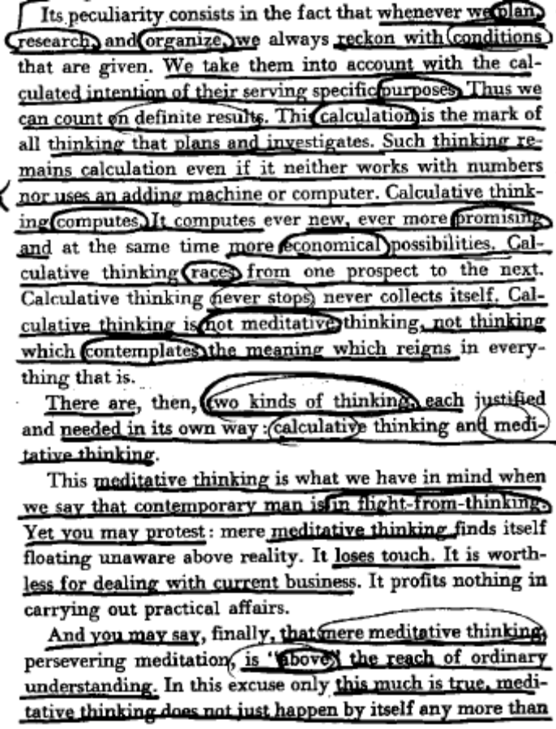
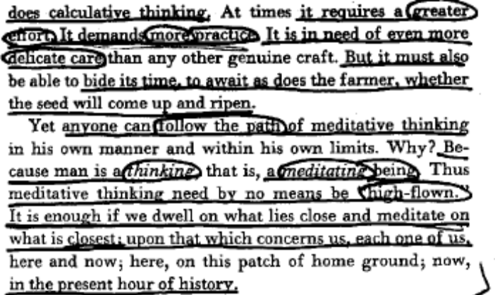

A2: Digger was a Nazi

Heidegger’s involvement with Nazism, while unfortunate, has little bearing on his philosophy insofar as his thought provides the basis for the most trenchant possible critique of the fascist project and domination in general.

Norman K. SWAZO, Prof. of Philosophy @ U. of Alaska- Fairbanks, 2002
[Crisis Theory and World Order: Heideggarian Reflections; SUNY Press; pg. 6]

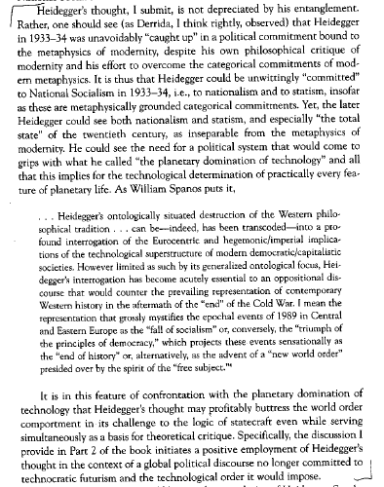

A2: Rawls

The Rawlsian project is ultimately insufficient for a critique of global politics- his philosophy is grounded firmly within the western metaphysical project, making radically alternative thought impossible.

Norman K. SWAZO, Prof. of Philosophy @ U. of Alaska- Fairbanks, 2002
[Crisis Theory and World Order: Heideggarian Reflections; SUNY Press; pg. 9-10]

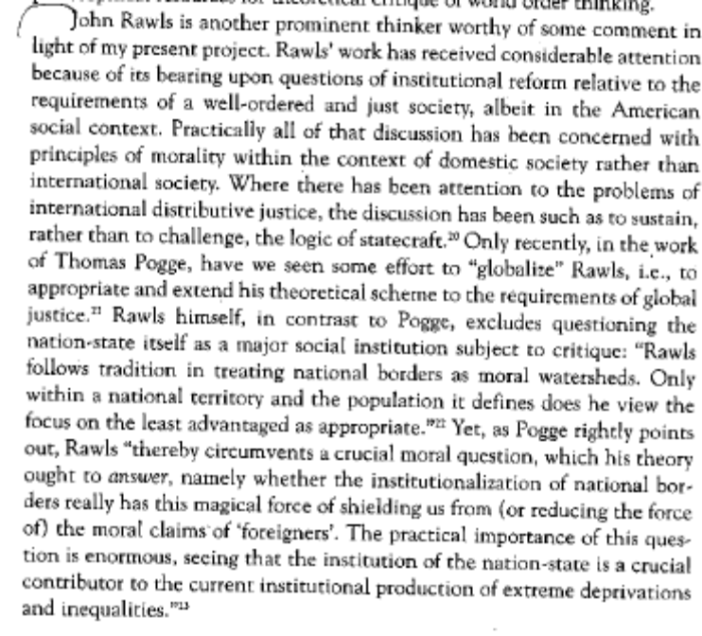
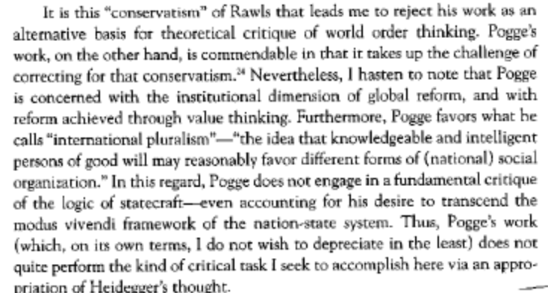

A2: general K’s of heidegger

Regardless of the intellectual positioning of their authors, there is no thinker whose project has the potential to reach so deeply into thought as to constitute the basis for a radical critique.

Norman K. SWAZO, Prof. of Philosophy @ U. of Alaska- Fairbanks, 2002
[Crisis Theory and World Order: Heideggarian Reflections; SUNY Press; pg. 10]

A2: pragmatism

The appeal to pragmatism does nothing but conceal the underlying existential anxiety of those who make such appeals to order and stability. A project of global transformation that does not entail a fundamental alteration of the ways in which we do thought does not go deep enough and is thus doomed to fail.

Norman K. SWAZO, Prof. of Philosophy @ U. of Alaska- Fairbanks, 2002
[Crisis Theory and World Order: Heideggarian Reflections; SUNY Press; pg. 12-13]
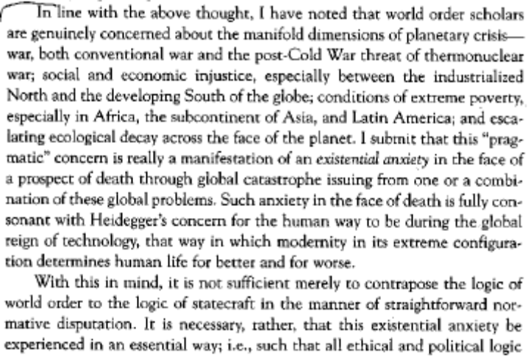
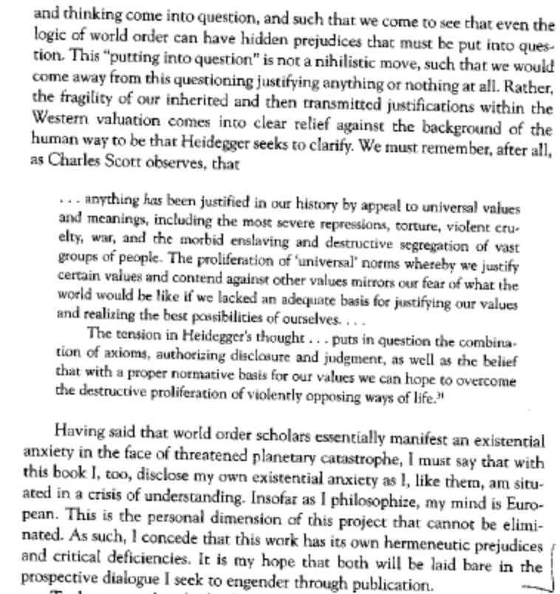

A2: positive Peace

The peace research project does not engage in deep enough reflection to say that it constitutes a non-calculative alternative mode of thought.

Norman K. SWAZO, Prof. of Philosophy @ U. of Alaska- Fairbanks, 2002
[Crisis Theory and World Order: Heideggarian Reflections; SUNY Press; pg. 18-9]

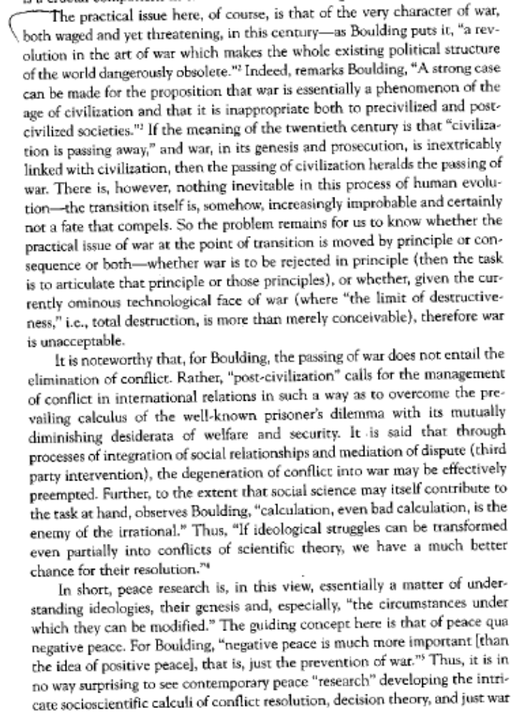
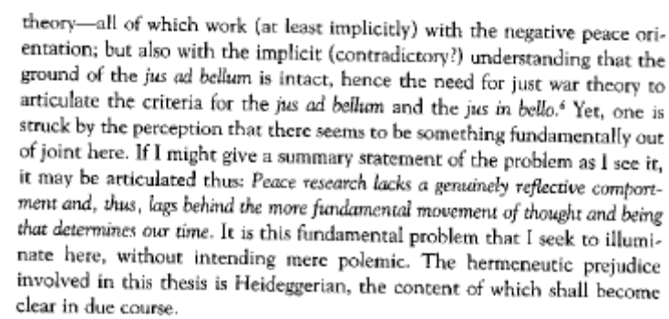

a2: FW

The question of the regulation of discourse requires extreme criticism- the attempt to regulate discourse resonates with untought- the affirmative’s attempt to moot the criticism is complicit with humanity’s flight from thought.

Norman K. SWAZO, Prof. of Philosophy @ U. of Alaska- Fairbanks, 2002
[Crisis Theory and World Order: Heideggarian Reflections; SUNY Press; pg. 148-9]

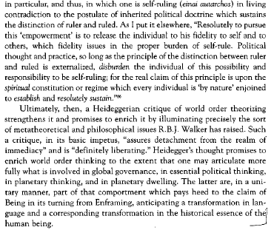
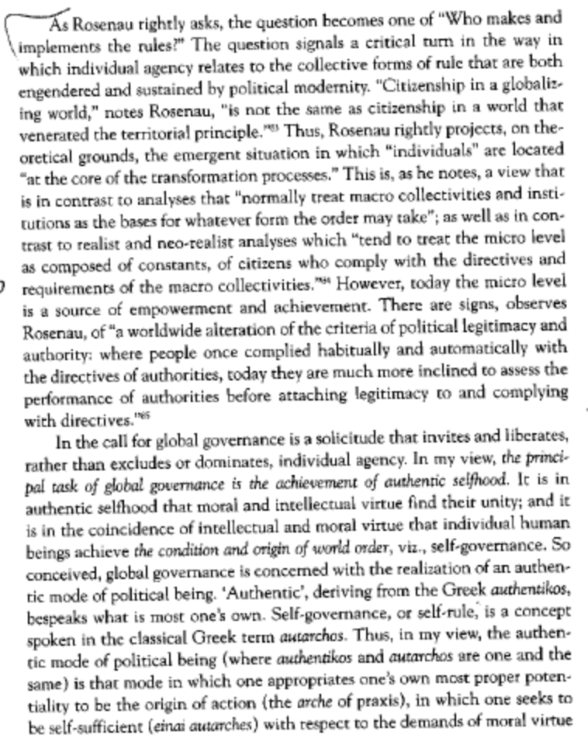

Alt: Rethink Thought

Only by reframing the way in which we approach thought itself may we bring about an escape from the consuming aspects of calculative thought. This reframing must seek to establish equilibrium between meditative and calculative thought and thus constitute a decisive and proper form of engagement with thinking.

Norman K. SWAZO, Prof. of Philosophy @ U. of Alaska- Fairbanks, 2002
[Crisis Theory and World Order: Heideggarian Reflections; SUNY Press; pg. 156-8]

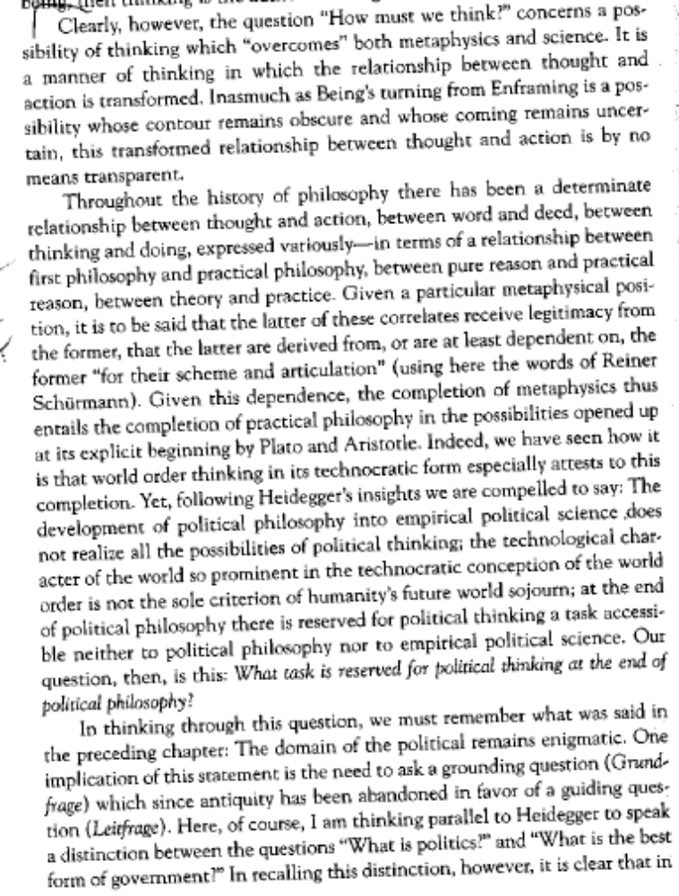
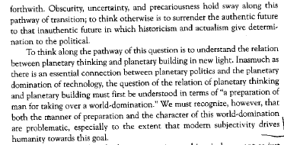
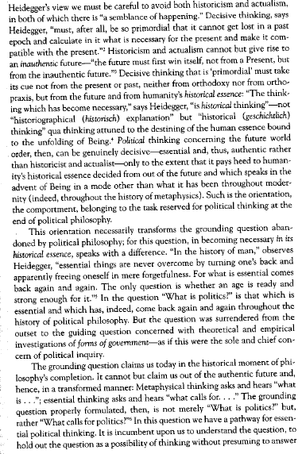

POEMS

I LIKE IT TO RAIN
By: Nii Ayikwei Parkes
[http://www.artistswithoutfrontiers.com/naparkes/index.html#]
Sometimes I like it to rain
Heavy, relentless and loud,
So you burrow into me like pain,
And inhale me slow and free.
I like the clouds to stretch
And darken, and shadow the world
As water mimics prison bars,
And we bond like inmates.
For at these times the sun
Restrains its prying eyes,
Neighbours melt in the gloom,
And we are alone in love
It is morning,
But neither day nor night;
You are neither you nor I
I am neither prisoner nor free.

DESIRE, by Mshairi [http://www.mshairi.com/blog/category/poetry/]
unadulterated longing sparks
unspoken words heard and accepted in
smouldering glances glowing smiles two souls
in need
without guile nor deception
hands arms and hearts mutely
reach out to count eyelashes to sketch
definitions of love
from heads to toes
entangled pulsating minds and spirits
in harmony and ardour while bodies
float down down
down
until with a hushed sigh they touch the bare naked floor

AFTER THE MEN HAVE GONE
By: Nii Ayikwei Parkes
[http://www.artistswithoutfrontiers.com/naparkes/index.html#]
there is a sideways walk
perfected long before man
invented side shuffles
to dance
a careful clatter free crawl
executed with aplomb
by crabs
emerging from caverns
beneath sea sand
the moon out the tide in
crabs cruise the shrunk shore
competing for food
and fun
and hollows
sidling about starstruck
in their blue-black
muscled-to-fit shells
they cavort and consult
clawing back
the land they own
after the men have gone

KNOWING ROBS US
Chinua Achebe, [http://www.randomhouse.com/boldtype/1298/achebe/scrapbook.html]
Knowing robs us of wonder.
Had it not ripped apart
the fearful robes of primordial Night
to steal the force that crafted horns
on doghead and sowed insurrection
overnight in the homely beak
of a hen; had reason not given us
assurance that day will daily break
and the sun's array return to disarm
night's fantastic figurations--
each daybreak
would be garlanded at the city gate
and escorted with royal drums
to a stupendous festival
of an amazed world.
One day
after the passage of a dark April storm
ecstatic birds followed its furrows
sowing songs of daybreak though the time
was now past noon, their sparkling
notes sprouting green incantations
everywhere to free the world
from harmattan death.
But for me
the celebration is make-believe;
the clamorous change of season
will darken the hills of Nsukka
for an hour or two when it comes;
no hurricane will hit my sky--
and no song of deliverance.

BELIEVING IN IRON
Yusef Komunyakaa [http://www.ibiblio.org/ipa/poems/komunyakaa/believing_in_iron.php]
The hills my brothers & I created
never balanced, & it took years
To discover how the world worked.
We could look at a tree of blackbirds
& tell you how many were there,
But with the scrap dealer
Our math was always off.
Weeks of lifting & grunting
Never added up to much,
But we couldn't stop
Believing in iron.
Abandoned trucks & cars
Were held to the ground
By thick, nostalgic fingers of vines
Strong as a dozen sharecroppers.
We'd return with our wheelbarrow
Groaning under a new load,
Yet tiger lilies lived better
In their languid, August domain.
Among paper & Coke bottles
Foundry smoke erased sunsets,
& we couldn't believe iron
Left men bent so close to the earth
As if the ore under their breath
Weighed down the gray sky.
Sometimes I dreamt how our hills
Washed into a sea of metal,
How it all became an anchor
For a warship or bomber
Out over trees with blooms
Too red to look at.

The Gods Wrote
Willie Kgositsile [http://southafrica.poetryinternationalweb.org/piw_cms/cms/cms_module/index.php?obj_id=5379]
We are breath of drop of rain
Grain of sea sand in the wind
We are root of baobab
Flesh of this soil
Blood of Congo brush elegant
As breast of dark cloud
Or milk flowing through the groaning years
We also know
Centuries with the taste
Of white shit down to the spine
The choice is ours
So is the life
The music of our laughter reborn
Tyityimba or boogaloo passion
Of the sun-eyed gods of our blood
Laughs in the nighttime, in the daytime too
And across America vicious cities
Clatter to the ground. Was it not
All written by the gods!
Turn the things! I said
Let them things roll
To the rhythm of our movement
Don't you know this is a love supreme!
John Coltrane John Coltrane tell the ancestors
We listened we heard your message
Tell them you gave us tracks to move
Trane and now we know
The choice is ours
So is the mind and the matches too
The choice is ours
So is the beginning
'We were not made eternally to weep'
The choice is ours
So is the need and the want too
The choice is ours
So is the vision of the day

